- Introduction

- Introduction

- A College Management System project allows Colleges and Universities to keep track of their enrolment, current students, keep record of old students, allows admin user to Remove Students and other activities related to tertiary education tasks.
- College Management System is an automated software that provides a more productive way of College Management.
- This College Management System project report is used to discuss the details needed for the system development.
- The project report on College Management System includes the project description, proposal and more which completes the whole documentation.

- Scope Of Work

- Scope Of Work

- In College Information Through this service one can access the complete information about the college campus such as courses available, admission procedure, placements, college events, achievements etc.

- This project deals with the various functioning in College management process.

- Admin can access and manage all the Data of Guest and Student users such as Managing Student Details, Admission Applications, Managing Students’ Feed Back, Managing Guests’ Feed Back, Managing Students’ Feed Back, Managing Guests’ Feed Back, and so on.

- Student users can Access Student’s (only his/her) own Data (View Student’s Personal Information View Student’s Academic Information), Give Feed Back, can go through Contact US Form after logging in as Student.

- Guest users can Apply for Admission, Give Feed Back about the college, use Contact US form for interacting with College / Admin, View Home Page, View About US Forms.

- An Existing System

- An Existing System

- In the existing system all the works are done manually. Students have to fill up admission form on paper and all the records are maintained on paper file.

- Let us take an example initially colleges appoint many employees to maintain the record of the student, teachers, other staff, employees' salaries, and student's fees.

- It was limited to a single system.
- It was less user-friendly.
- It requires more no of employees need to work.
- It was time consuming process.

- Need of Proposed System

- Need of Proposed System

- This is a web-related application that permits us to approach entire knowledge regarding the college, employees, students, faculties etc.

- This application is also called as College management system. It offers an actual trip of the college campus.

- In order to solve these problems, a new system has been created, that attempts to operate the whole procedure considering the database integration approach.

- Feasibility Study

- Feasibility Study

5.1 Need of Feasibility Study:
- Answer the question whether a new system is to be installed or not.
- Determine the potential of the existing system.
- Improve the existing system.
- Know what should be embedded in the new system.
- Define the problem and objective involved in the project.
- Avoid cash implementation of a new system.
- Avoid the “Hardware approach”.

5.2 Types of Feasibility Study:
- Feasibility is a test of system proposal according to its workability impact on the organization, ability to meet user needs & effective use of resources.

- A feasibility study must be thorough, unbiased and objective.

- The purpose of the feasibility study is to determine whether the problem can be with minimum costs as soon as possible.

- Five key areas of feasibility study are listed below:
- Operational feasibility
- Technical Feasibility
- Legal/Ethical Feasibility Study
- Schedule Feasibility Study
- Resource Feasibility Study
- Cultural Feasibility Study

- Operational Feasibility Study:

The current system is manual. Thus processing large amount of data becomes a cumbersome activity. Reports that are generated are difficult to prepare manually and are also error prone. Operationally the Proposed system is feasibility because there are sufficient supports for project from management. It will be running smoother and faster that of existing system.

- Technical Feasibility Study:

Generally, new system brings new technology into an organization. The proposed system requires technology and equipment, which can be obtained. the operating system has the technical capacity to hold the data required to use the proposed system. The present equipment technology assures technical guarantee of accuracy, reliability and ease of access.

- Legal/Ethical Feasibility Study:

Determines whether the proposed system conflicts with legal requirements.

- Schedule Feasibility Study:

A project will fail if it takes too long to be completed before it is useful.
Typically, this means estimating how long the system will take to develop, and if it can be completed in given time period using some methods like payback period. Schedule feasibility is a measure of how reasonable the project timetable is. Given our technical expertise, are the project deadlines reasonable? Some projects are initiated with specific deadlines. You need to determine whether the deadlines are mandatory or desirable.

- Resource Feasibility Study:

This involves questions such as how much time is available to build the new system, when it can be built, whether it interferes with normal business operations, type and amount of resources required, dependencies.

- Cultural Feasibility Study:

In this stage, the project's alternatives are evaluated for their impact on the local and generated culture. For example, environmental factors need to be considered and these factors are to be well known. Further an enterprise's own culture can clash with the results of the project.

- System Features

- System Features

- This College Management System is a must-have for every educational institute that wants to scale higher heights and want to be well known for academic excellence.

- But with the inception of college ERP software, these have been greatly reduced and it has made provision for better academic performance with its mind-blowing features.

- Student Admission Management.
- Student Authentication.
- Student Data Updation.
- Student Data Deletion.
- Student Feedbacks Management.
- Student Contact US Management.
- Guest Feedbacks Management.
- Guest Contact US Management.
- Guests can Apply for Admission in the college.
- Guests can Give Feedbacks.
- Guests can interact with College / Admin using Contact US forms.
- Admin can View Current and Removed students’ Details.
- And so on.

7. Hardware and Software Requirement

- Hardware and Software Requirement

7.1 Hardware Requirements
Requirements | Minimum Values
Processor | Intel(R) Core(TM) i5-6400 or Higher
CPU | 2.70 GHz or Higher
RAM | 8 GB or More
Hard Disk | 256 GB or More

7.2 Software Requirements
Requirements | Minimum Values
Front-End | Asp.Net ( HTML,CSS, Java Script ,C#)
Back-End | My SQL Server
Server | SQL Server 2008 or Higher
Database | My SQL
Office | MS Office 2016  (MS Word, MS Power Point)
Software | Visual Studio 2010 or Higher
Operating System | Windows 10 Home Basic-E Series, 13 Processor or Higher

8. Data Flow Diagram (DFD)

8. Data Flow Diagram (DFD)

- Symbols Used For Creation of Data Flow Diagrams :

1. Process:
- Here flow of data is transformed. Ex: supply of goods etc.

2. External entity:
- A source of the destination of the data which is external is to system. Ex: Supplier, customers.

3. Data flow:
- It is a Pack of data. It may be in the form of document, data, letters etc.

4. Data store:
- Any data will be stored, but no reference to the physical method of sorting.

- Context Level DFD :

College Management System
Request Response

Admin

Student

Response Request

Guest

- (Admin) Zero Level DFD :
1.0
Login
Admin
Admin
Login
DB
Request Request

Response Response

New Student Admission Applications
DB
2.0 Manage Admission
Request Request

Response Response

Request Request
Student Details
DB
3.0 Manage Student

Response Response

Request Request
FeedBack
DB
4.0 Manage Feedbacks

Response Response

Request Request
Contact US
DB
5.0 Manage Contact US

Response Response

- (Admin) First Level DFD :

1.0 Login :

Admin
Login
DB
1.1
Log in

Admin
Request
Response
Response
Request
Response
Response

2.0 Manage Admission :

2.1
Admit Student
Admin
Request Insert Information
Request

Response
Response
New Student Admission Applications DB
2.2
Delete Data
Request Delete Information
Request
Response
Response

3.0 Manage Student :

3.1
Insert Data
Admin
Request Insert Information
Request

Response
Response
Student
DB
3.2
Update Data
Request Update Information
Request
Response
Response

3.3
Delete Data
Request Delete Information
Request

Response

Response

4.0 Manage Feedbacks :

4.1
View Data
Admin
Request View Information
Request

Response
Response
FeedBack
DB
4.2
Delete Data
Request Delete Information
Request
Response
Response

5.0 Manage Contact US :

4.1
View Data
Admin
Request View Information
Request

Response
Response
Contact US
DB
4.2
Delete Data
Request Delete Information
Request
Response
Response

- (Guest) Zero Level DFD :

New Students Admission Applications
DB
1.0
Apply For Admission
Request Request
Guest

Response Response

2.0
Give
Feed Back
Request Request
Feed Back
DB

Response Response

3.0
Contact US

Request Request
Contact US
DB

Response Response

- (Guest) First Level DFD :

1.0 Apply For Admission :

1.1
Apply For Admission

Guest
Request
Information
Response
Response
New Students Admission Applications
DB

2.0 Give Feed Back :

Feed Back
DB
2.1
Give
Feed Back

Guest
Feed Back
Information
Response
Response

3.0 Contact US :

Contact US
DB
3.1
Contact
US

Guest
Qestions/Query
Information
Response
Response

- (Student) Zero Level DFD :

1.0
Login
Request Request

Student

Login
DB

Response Response

2.0
View Student Data
Request Request
Student
DB

Response Response

3.0
Feed Back
Feed Back Feed Back
Feed Back
DB

Response Response

4.0
Contact US
Query / Questions Request
Contact US
DB

Response Response

- (Student) First Level DFD :

1.0 Login :

1.1
Log in

Student
Request
Login Information
Response
Response
1.2
Forgot Password
1.2
Forgot Password
Request
Request Login Information
Response
Response
Student
Login
DB

Student

2.0 View Student Data :

Student Details
DB
Student Details
DB

2.1
View Personal Information
Student
Information
Request

Response
Response
2.2
View Academic Information

Information
Request
Response
Response

3.0 Give Feed Back :

Feed Back
DB
3.1
Give
Feed Back

Student
Feed Back
Information
Response
Response

4.0 Contact US :

Contact US
DB
4.1
Contact
US

Student
Questions/Query
Information
Response
Response

9. Database Layout / File Layout

9. Database Layout / File Layout

9.1 Table Name: Admin_Login

Sr. No | Field Name | Data Type | Constraints
1. | LoginID | int | Primary Key,  Not Null
2. | LoginPassword | varchar(50) | Not Null

9.2 Table Name: Student_Login

Sr. No | Field Name | Data Type | Constraints
1. | LoginID | int | Primary Key,  Not Null
2. | LoginPassword | varchar(50) | Not Null

9.3 Table Name: Contact_US

Sr. No | Field Name | Data Type | Constraints
1. | cid | int | Primary Key,  Not Null
2. | cutype | varchar(20) | Not Null
3. | cunm | varchar(50) | Not Null
4. | cumno | numeric(18, 0) | Not Null
5. | cuemail | varchar(50) | Not Null
6. | cumsg | varchar(MAX) | Not Null

9.4 Table Name: FeedBack

Sr. No | Field Name | Data Type | Constraints
1. | fid | int | Primary Key,  Not Null
2. | futype | varchar(20) | Not Null
3. | funm | varchar(50) | Not Null
4. | fumno | numeric(18, 0) | Not Null
5. | fuemail | varchar(50) | Not Null
6. | fumsg | varchar(MAX) | Not Null

9.5 Table Name: New_Student_Admission_Applications

Sr. No | Field Name | Data Type | Constraints
1. | StdAID | int | Primary Key, Not Null
2. | StdAdate | Date | Not Null
3. | StdAPassSizePhoto | Image | Not Null
4. | StdAfname | varchar(50) | Not Null
5. | StdASalutation | varchar(10) | Not Null
6. | StdAmname | varchar(50) | Not Null
7. | StdAlname | varchar(50) | Not Null
8. | StdAbdate | varchar(50) | Not Null
9. | StdABldgroup | varchar(10) | Not Null
10. | StdAEmail | varchar(50) | Not Null
11. | StdAMNo | numeric(18, 0) | Not Null
12. | StdAGen | varchar(10) | Not Null
13. | StdAMaritalStatus | varchar(10) | Not Null
14. | StdAReligion | varchar(30) | Not Null
15. | StdACasteCat | varchar(10) | Not Null
16. | StdAFatherSpouseName | varchar(50) | Not Null
17. | StdAFatherSpouseMNo | numeric(18, 0) | Not Null
18. | StfAMotherName | varchar(50) | Not Null
19. | StfAMotherMNo | numeric(18, 0) | Not Null
20. | StdAFatherSpouseOccupation | varchar(30) | Not Null
21. | StdAAnnualIncome | numeric(10, 0) | Not Null
22. | StdAPresentAddr | varchar(80) | Not Null
23. | StdAPresentAddrCity | varchar(30) | Not Null
24. | StdAPresentAddrPinCode | numeric(18, 0) | Not Null
25. | StdAPresentAddrState | varchar(30) | Not Null
26. | StdAPrmntAddr | varchar(80) | Not Null
27. | StdAPrmntAddrCity | varchar(30) | Not Null
28. | StdAPrmntAddrPinCode | numeric(18, 0) | Not Null
29. | StdAPrmntAddrState | varchar(30) | Not Null
30. | StdACourse | varchar(20) | Not Null
31. | StdAMedOfInstrctn | varchar(20) | Not Null
32. | StdASemester | varchar(20) | Not Null
33. | StdAClsXSchool | varchar(30) | Not Null
34. | StdAClsXBoard | varchar(30) | Not Null
35. | StdAClsXCity | varchar(30) | Not Null
36. | StdAClsXMedOfInstrctn | varchar(20) | Not Null
37. | StdAClsXYearOfPassing | varchar(20) | Not Null
38. | StdAClsXPercentage | float | Not Null
39. | StdAClsXMarksheet | Image | Not Null
40. | StdAClsXIISchool | varchar(30) | Not Null
41. | StdAClsXIIBoard | varchar(30) | Not Null
42. | StdAClsXIICity | varchar(30) | Not Null
43. | StdAClsXIIMedOfInstrctn | varchar(20) | Not Null
44. | StdAClsXIIYearOfPassing | varchar(10) | Not Null
45. | StdAClsXIIStreamDiscipline | varchar(10) | Not Null
46. | StdAClsXIIPercentage | float | Not Null
47. | StdAClsXIIMarksheet | Image | Not Null
48. | StdASICollege | varchar(30) | Not Null
49. | StdASIUniversity | varchar(30) | Not Null
50. | StdASICity | varchar(30) | Not Null
51. | StdASIYearOfPassing | varchar(20) | Not Null
52. | StdASIPerGPA | float | Not Null
53. | StdASIMarksheet | Image | Not Null
54. | StdASIICollege | varchar(30) | Not Null
55. | StdASIIUniversity | varchar(30) | Not Null
56. | StdASIICity | varchar(30) | Not Null
57. | StdASIIYearOfPassing | varchar(20) | Not Null
58. | StdASIIPerGPA | float | Not Null
59. | StdASIIMarksheet | Image | Not Null
60. | StdASIIICollege | varchar(30) | Not Null
61. | StdASIIIUniversity | varchar(30) | Not Null
62. | StdASIIICity | varchar(30) | Not Null
63. | StdASIIIYearOfPassing | varchar(20) | Not Null
64. | StdASIIIPerGPA | float | Not Null
65. | StdASIIIMarksheet | Image | Not Null
66. | StdASIVCollege | varchar(30) | Not Null
67. | StdASIVUniversity | varchar(30) | Not Null
68. | StdASIVCity | varchar(30) | Not Null
69. | StdASIVYearOfPassing | varchar(20) | Not Null
70. | StdASIVPerGPA | float | Not Null
71. | StdASIVMarksheet | Image | Not Null
72. | StdASVCollege | varchar(30) | Not Null
73. | StdASVUniversity | varchar(30) | Not Null
74. | StdASVCity | varchar(30) | Not Null
75. | StdASVYearOfPassing | varchar(20) | Not Null
76. | StdASVPerGPA | float | Not Null
77. | StdASVMarksheet | Image | Not Null
78. | StdASignature | Image | Not Null
79. | StdASecQue | varchar(50) | Not Null
80. | StdASecAns | varchar(50) | Not Null

9.6 Table Name: Student_Details

Sr. No | Field Name | Data Type | Constraints
1. | StdAdmissionID | int | Primary Key, Not Null
2. | StdAdmissionDate | Date | Not Null
3. | StdAdmsnCnclnDate | Date | Not Null
4. | StdAdmsnCnclnReason | varchar(150) | Not Null
5. | StdAStatus | varchar(30) | Not Null
6. | StdApplicationID | int | Not Null
7. | StdApplicationDate | varchar(50) | Not Null
8. | StdAPassSizePhoto | Image | Not Null
9. | StdASalutation | varchar(10) | Not Null
10. | StdAfname | varchar(50) | Not Null
11. | StdAmname | varchar(50) | Not Null
12. | StdAlname | varchar(50) | Not Null
13. | StdAbdate | varchar(50) | Not Null
14. | StdABldgroup | varchar(10) | Not Null
15. | StdAEmail | varchar(50) | Not Null
16. | StdAMNo | numeric(18, 0) | Not Null
17. | StdAGen | varchar(10) | Not Null
18. | StdAMaritalStatus | varchar(10) | Not Null
19. | StdAReligion | varchar(30) | Not Null
20. | StdACasteCat | varchar(10) | Not Null
21. | StdAFatherSpouseName | varchar(50) | Not Null
22. | StdAFatherSpouseMNo | numeric(18, 0) | Not Null
23. | StdAMotherName | varchar(50) | Not Null
24. | StdAMotherMNo | numeric(18, 0) | Not Null
25. | StdAFatherSpouseOccupation | varchar(30) | Not Null
26. | StdAAnnualIncome | numeric(10, 0) | Not Null
27. | StdAPresentAddr | varchar(80) | Not Null
28. | StdAPresentAddrCity | varchar(30) | Not Null
29. | StdAPresentAddrPinCode | numeric(18, 0) | Not Null
30. | StdAPresentAddrState | varchar(30) | Not Null
31. | StdAPrmntAddr | varchar(80) | Not Null
32. | StdAPrmntAddrCity | varchar(30) | Not Null
33. | StdAPrmntAddrPinCode | numeric(18, 0) | Not Null
34. | StdAPrmntAddrState | varchar(30) | Not Null
35. | StdACourse | varchar(20) | Not Null
36. | StdAMedOfInstrctn | varchar(20) | Not Null
37. | StdASemester | varchar(20) | Not Null
38. | StdABatch | varchar(30) | Not Null
39. | StdAClsXSchool | varchar(30) | Not Null
40. | StdAClsXBoard | varchar(30) | Not Null
41. | StdAClsXCity | varchar(30) | Not Null
42. | StdAClsXMedOfInstrctn | varchar(20) | Not Null
43. | StdAClsXYearOfPassing | varchar(20) | Not Null
44. | StdAClsXPercentage | float | Not Null
45. | StdAClsXMarksheet | Image | Not Null
46. | StdAClsXIISchool | varchar(30) | Not Null
47. | StdAClsXIIBoard | varchar(30) | Not Null
48. | StdAClsXIICity | varchar(30) | Not Null
49. | StdAClsXIIMedOfInstrctn | varchar(20) | Not Null
50. | StdAClsXIIYearOfPassing | varchar(10) | Not Null
51. | StdAClsXIIStreamDiscipline | varchar(10) | Not Null
52. | StdAClsXIIPercentage | float | Not Null
53. | StdAClsXIIMarksheet | Image | Not Null
54. | StdASICollege | varchar(30) | Not Null
55. | StdASIUniversity | varchar(30) | Not Null
56. | StdASICity | varchar(30) | Not Null
57. | StdASIYearOfPassing | varchar(20) | Not Null
58. | StdASIPerGPA | float | Not Null
59. | StdASIMarksheet | Image | Not Null
60. | StdASIICollege | varchar(30) | Not Null
61. | StdASIIUniversity | varchar(30) | Not Null
62. | StdASIICity | varchar(30) | Not Null
63. | StdASIIYearOfPassing | varchar(20) | Not Null
64. | StdASIIPerGPA | float | Not Null
65. | StdASIIMarksheet | Image | Not Null
66. | StdASIIICollege | varchar(30) | Not Null
67. | StdASIIIUniversity | varchar(30) | Not Null
68. | StdASIIICity | varchar(30) | Not Null
69. | StdASIIIYearOfPassing | varchar(20) | Not Null
70. | StdASIIIPerGPA | float | Not Null
71. | StdASIIIMarksheet | Image | Not Null
72. | StdASIVCollege | varchar(30) | Not Null
73. | StdASIVUniversity | varchar(30) | Not Null
74. | StdASIVCity | varchar(30) | Not Null
75. | StdASIVYearOfPassing | varchar(20) | Not Null
76. | StdASIVPerGPA | float | Not Null
77. | StdASIVMarksheet | Image | Not Null
78. | StdASVCollege | varchar(30) | Not Null
79. | StdASVUniversity | varchar(30) | Not Null
80. | StdASVCity | varchar(30) | Not Null
81. | StdASVYearOfPassing | varchar(20) | Not Null
82. | StdASVPerGPA | float | Not Null
83. | StdASVMarksheet | Image | Not Null
84. | StdASVICollege | varchar(30) | Not Null
85. | StdASVIUniversity | varchar(30) | Not Null
86. | StdASVICity | varchar(30) | Not Null
87. | StdASVIYearOfPassing | varchar(20) | Not Null
88. | StdASVIPerGPA | float | Not Null
89. | StdASVIMarksheet | Image | Not Null
90. | StdADegCertificate | Image | Not Null
91. | StdATrnsfrCertificate | Image | Not Null
92. | StdASignature | Image | Not Null
93. | StdASecQue | varchar(50) | Not Null
94. | StdASecAns | varchar(50) | Not Null

10. Design Of Input-Output Screens & Reports

10. Design Of Input-Output Screens & Reports
- 1.1 Log in Web Form :
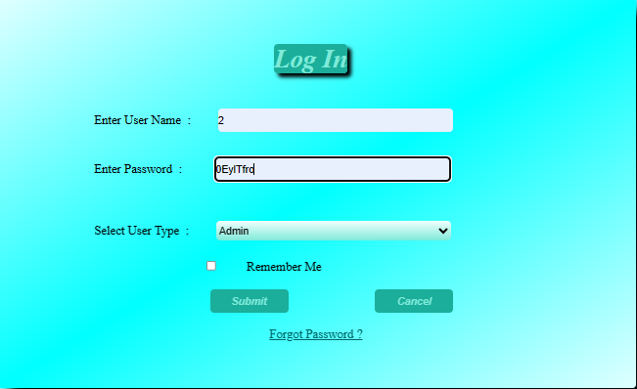
- 1.2 Log in Web Form :
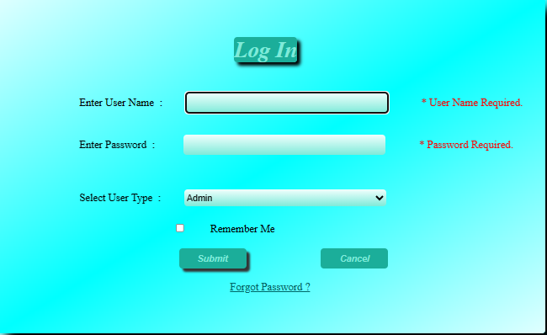

- 2.1 Apply For Admission Web Form :

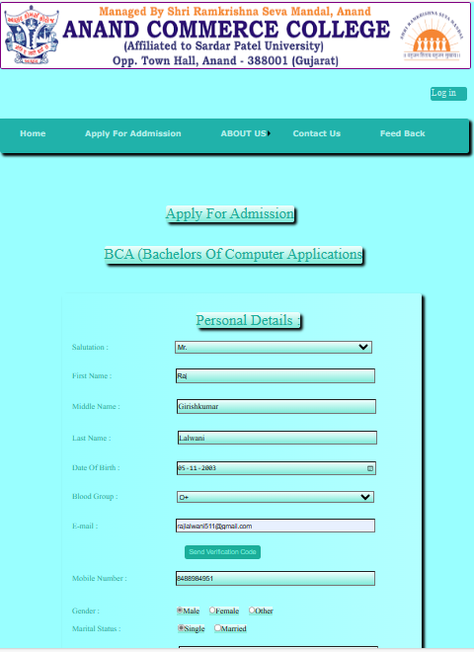

- 2.2 Apply For Admission Web Form :



- 2.3 Apply For Admission Web Form :

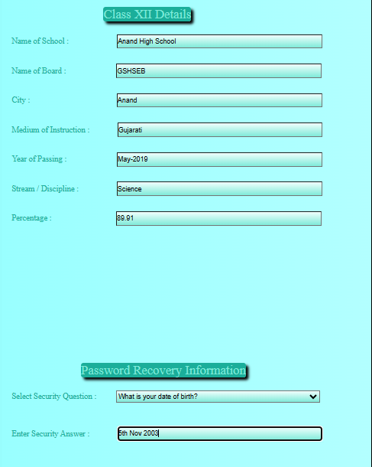

- 2.4 Apply For Admission Web Form :

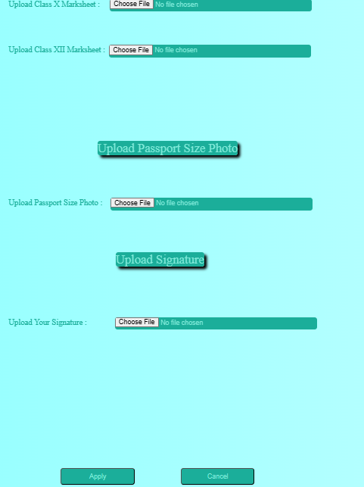

- 3.1 Forgot Password Web Form :
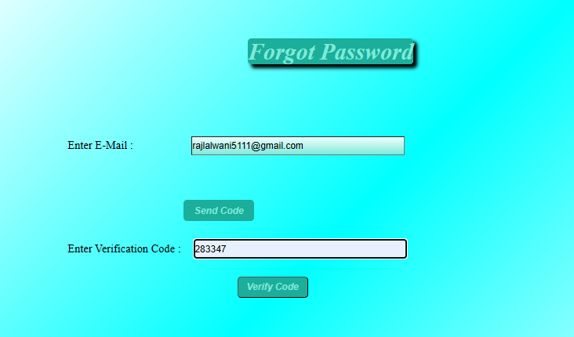

- 3.2 Forgot Password Web Form :

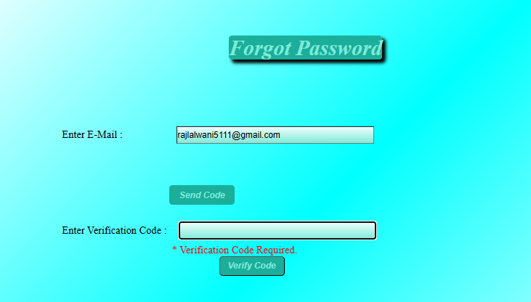

- Home Page Web Form :


- Manage Feedbacks Web Form :

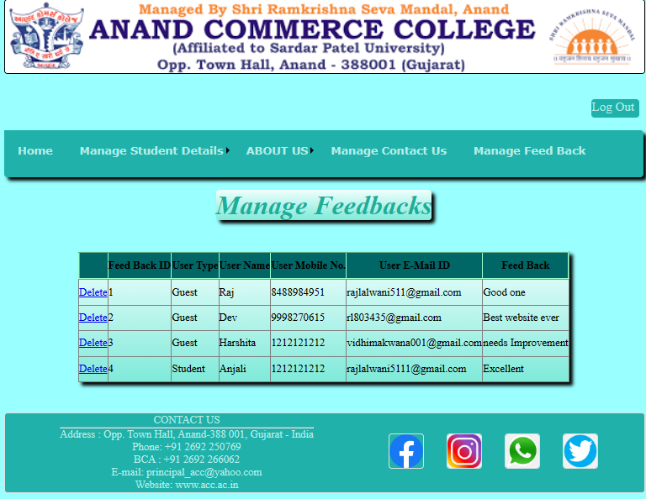
- Manage Contact US Web Form :

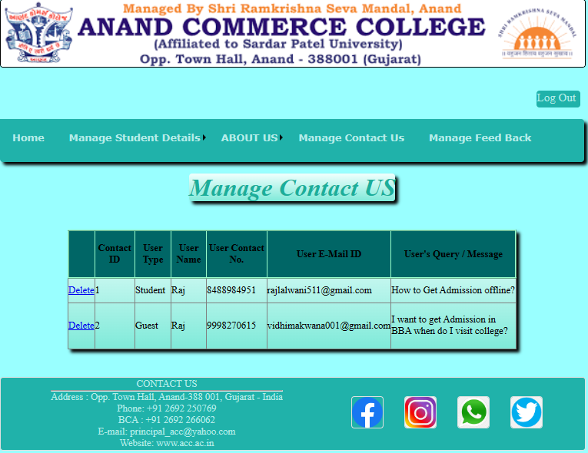

11. Testing Procedures
&
Implementation Phases

11. Testing Procedures & Implementation Phases

11.1 Testing Procedures:
1. Functional Testing :
Functional testing is an essential part of website, as it ensures that all the functions on the website work as expected. The following are the steps Involved in functional testing for a website:
- Identify the functions to be tested: This involves creating a list of all the interactive elements on the website, such as links, forms, navigation menus, and buttons.
- Define the expected behavior: This involves defining the expected behavior of each function. For example, a link should take the user to the correct page, a form should submit the data correctly, and a button should perform the expected action.
- Create test cases: This involves creating test cases that cover all the possible scenarios for each function. For example, a test case for a form might include testing what happens when the user enters invalid data, or when the user submits the form without filling out all the required fields.
- Execute the test cases: This involves running the test cases and verifying that the functions work as expected. Any issues or bugs that are discovered during testing should be documented and reported.
- Retest: After any issues or bugs are fixed, the functions should be retested to ensure that the changes have been made correctly.
- Sign off: Once all the functions have been tested and any issues have been fixed, the functional testing phase can be signed off, and the website can move on to the next phase of testing or be launched.

2. Usability Testing :
Scalability testing is a critical part of website, as it ensures that the website is easy to use and navigate. The following are the steps involved in usability testing for a website:
- Identify the user groups: This involves identifying the target audience for the website, such as age, gender, technical proficiency, and experience with similar websites.
- Define the usability goals: This involves defining the usability goals of the website, such as the ease of use, learnability, efficiency, and user satisfaction.
- Create test scenarios: This involves creating realistic scenarios that the users will encounter when using the website. For example, a scenario might be to find a specific product or service, place an order, or contact customer service.
- Recruit participants: This involves recruiting participants who match the target audience and have not previously used the website. The participants should be briefed on the usability goals and test scenarios.

- Conduct the testing: This involves observing the participants as they use the website to complete the test scenarios. The participants should be encouraged to think out loud and provide feedback on the usability of the website.
- Analyze the results: This involves analyzing the feedback provided by the participants and identifying any usability issues or areas for improvement. The results should be documented and prioritized based on their impact on the usability goals.
- Fix the issues: This involves fixing the usability issues and retesting the website to ensure that the changes have been made correctly.
- Sign off: Once all the usability issues have been fixed, and the website meets the usability goals, the usability testing phase can be signed off, and the website can move on to the next phase of testing or be launched.

3. Compatibility Testing :
Compatibility testing is a crucial part of website documentation, as it ensures that the website works correctly on different browsers, devices, and operating systems. The following are the steps involved in compatibility testing for a website:
- Identify the target browsers and devices: This involves identifying the browsers and devices that the website must work on. This can be determined by analyzing website traffic and user data.
- Create a testing plan: This involves creating a plan that outlines the specific combinations of browsers, devices, and operating systems to be tested. The plan should also include the testing methodology and the tools to be used for testing.
- Test the website: This involves testing the website on the target browsers, devices, and operating systems. This can be done manually or by using automated testing tools.
- Identify compatibility issues: This involves identifying any compatibility issues or inconsistencies that occur when the website is tested on different browsers, devices, and operating systems.
- Document the issues: This involves documenting the compatibility issues found during testing, including screenshots and error messages. The issues should be prioritized based on their impact on the user experience and the target audience.
- Fix the issues: This involves fixing the compatibility issues and retesting the website to ensure that the changes have been made correctly.
- Sign off: Once all the compatibility issues have been fixed, and the website works correctly on all the target browsers, devices, and operating systems, the compatibility testing phase can be signed off, and the website can move on to the next phase of testing or be launched.

4. Performance Testing :
Performance testing is a critical part of website documentation, as it ensures that the website can handle expected user traffic and operate efficiently under load. The following are the steps involved in performance testing for a website:
- Identify the performance goals: This involves identifying the expected user traffic, response time, and throughput for the website.
- Create a testing plan: This involves creating a plan that outlines the specific scenarios to be tested, the number of users to simulate, and the tools to be used for testing.
- Test the website: This involves testing the website under different load scenarios to identify its response time, throughput, and resource utilization. This can be done manually or by using automated testing tools.
- Analyze the results: This involves analyzing the results of the performance testing to identify any performance issues or bottlenecks. The results should be documented and prioritized based on their impact on the performance goals.
- Fix the issues: This involves fixing the performance issues and retesting the website to ensure that the changes have been made correctly.
- Sign off: Once all the performance issues have been fixed, and the website meets the performance goals, the performance testing phase can be signed off, and the website can move on to the next phase of testing or be launched.

5. Security Testing :
Security testing is a key part of website documentation, as it helps to identify vulnerabilities, threats, and risks that could be exploited by malicious actors. Generally, security testing involves a combination of manual testing and automated tools to identify potential issues. Manual testing may involve a code review or an audit of security practices, while automated tools can scan websites for potential issues such as cross-site scripting and SQL injection vulnerabilities. Once potential issues have been identified, they can then be addressed by implementing the necessary security practices, such as input validation and proper authentication and authorization.

11.2 Implementation phases

- Planning
Planning is an important step in creating any kind of documentation, including website documentation. Here are some key steps to consider when planning your website documentation:
- Identify the purpose and audience: Determine the purpose of your website documentation and who your target audience is. This will help you tailor your content and language to meet their needs.
- Define the scope: Determine the scope of your website documentation, which includes the specific topics you will cover and the level of detail you will go into for each topic. This will help you create an outline of your documentation.
- Determine the format: Decide on the format of your website documentation. Will it be a series of web pages, a PDF, or something else? This will help you decide on the tools and software you will use to create your documentation.
- Create an outline: Create an outline of your website documentation that includes the topics you will cover and the order in which you will cover them. This will help you organize your content and ensure that you cover all necessary information.
- Write and revise: Write your website documentation, making sure to use clear and concise language. Revise your content to ensure that it is accurate, complete, and easy to understand.
- Test and review: Test your website documentation with a small group of users to make sure it is easy to use and understand. Review your documentation regularly to ensure that it remains up-to-date and relevant.

2. Design
The design phase in website documentation refers to the process of creating a visual and structural plan for the website. During this phase, you will determine the look and feel of the website, the layout and organization of the content, and the navigation structure.
- Review the website's purpose and audience: Review the website's purpose and audience to ensure that the design aligns with the website's goals and target audience.
- Create a sitemap: Create a sitemap that outlines the website's structure and the hierarchy of the pages. This will help ensure that the content is organized in a logical and intuitive way.
- Develop wire frames: Develop wire frames, which are visual representations of the layout and content of the website's pages. Wire frames can help you test and refine the design before moving on to more detailed design work.
- Choose a colour scheme and typography: Choose a colour scheme and typography that aligns with the website's purpose and brand. This will help create a cohesive and professional look and feel for the website.

- Create a mock-up: Create a mock-up that incorporates the wire frames and the chosen colour scheme and typography. This will give you a more detailed and accurate representation of the website's design.
- Test and iterate: Test the mock-up with a small group of users to ensure that it is easy to use and understand. Iterate on the design based on user feedback and revise as needed.

3. Development
The development phase in website documentation refers to the process of turning the website design into a functional website that can be accessed and used by the website's audience. This phase involves a range of technical tasks, including coding, testing, and deployment.
- Build the website's infrastructure: Build the website's infrastructure, which includes setting up the server, creating a database, and configuring the content management system (CMS) or other software tools that will be used to develop the website.
- Develop the front-end: Develop the front-end of the website, which involves creating the user interface and the visual elements that the website's audience will see and interact with.
- Develop the back-end: Develop the back-end of the website, which involves creating the server-side logic and the database management that powers the website's functionality.
- Integrate content: Integrate content into the website, which involves adding text, images, videos, and other media to the website's pages.
- Test and debug: Test and debug the website to ensure that it is functioning properly and that there are no errors or glitches that could impact the website's usability or performance.
- Optimize for performance: Optimize the website's performance by testing the website's loading speed, ensuring that it is mobile-friendly, and optimizing the website's code to improve its speed and efficiency.
- Deploy the website: Deploy the website to the server and make it accessible to the website's audience.

4. Testing
Testing is a critical phase in the implementation of a website, as it helps to identify and correct any issues or bugs that could impact the website's usability or functionality. During the testing phase, you should test the website thoroughly to ensure that it meets the requirements and objectives of the project, and that it is easy to use and error-free.
- Develop a testing plan: Develop a testing plan that outlines the testing process, the scope of the testing, the testing tools and methods to be used, and the expected results.
- Test functionality: Test the website's functionality by going through all the website's pages and features to ensure that they are working as intended.

- Test usability: Test the website's usability by performing user testing to ensure that the website is easy to navigate and understand, and that users can complete tasks without confusion or difficulty.
- Test compatibility: Test the website's compatibility by checking that it works on all major browsers and devices, including desktops, laptops, tablets, and smart phones.
- Test security: Test the website's security to ensure that it is protected against common security threats such as hacking, malware, and data breaches.
- Report and fix issues: Report any issues or bugs that are found during testing, and work with the development team to fix them as quickly as possible.
- Retest: Retest the website after the issues have been fixed to ensure that they have been resolved and that there are no new issues.

5. Launch
The launch phase in website implementation refers to the process of making the website available to the public. This involves taking the website out of the development environment and moving it to the production environment where it can be accessed by the website's audience.
- Final testing: Before launching the website, it is important to perform final testing to ensure that everything is working properly and that there are no last-minute issues.
- Set up hosting and domain: Set up the website's hosting and domain name so that it can be accessed by the website's audience.
- Transfer files and database: Transfer the website's files and database from the development environment to the production environment.
- Set up analytics and tracking: Set up analytics and tracking tools to monitor the website's traffic and user behaviour.
- Create a backup plan: Create a backup plan to ensure that the website can be restored if anything goes wrong during or after the launch.
- Launch the website: Launch the website and make it available to the website's audience.
- Monitor and maintain: After launching the website, it is important to monitor and maintain it to ensure that it is performing as expected and that there are no issues or security threats.

6. Maintenance
Maintenance is a critical part of the implementation phase in website development. Maintaining a website ensures that it continues to perform as intended, remains secure, and meets the evolving needs of its audience. Here are some key steps to consider during the maintenance phase of website implementation:

- Regular backups: Regularly back up the website's files and database to ensure that data is not lost in the event of a security breach, data loss, or other issues.
- Monitor website performance: Monitor the website's performance by using analytics and tracking tools to track website traffic, user behaviour, and other metrics that help to assess website performance.
- Update website software: Keep the website's software, including the CMS and other plug-ins or modules, up to date with the latest releases and patches to ensure that the website remains secure and optimized for performance.
- Check for broken links and errors: Regularly check for broken links and errors that could impact the website's usability or search engine rankings.

- Fix issues and bugs: As issues or bugs arise, promptly work to fix them to ensure that the website remains functional and secure.
- Check for security vulnerabilities: Regularly check the website for security vulnerabilities and take steps to address any issues that are found.
- Review and update content: Regularly review and update the website's content to ensure that it remains fresh, relevant, and engaging for the website's audience.

12. Limitations

12. Limitations

- Limited compatibility with older web browsers, which may result in degraded performance or usability.

- Certain features may be disabled or unavailable during periods of high traffic or server load.

- Features of the website may only be available to users who have created an account.

- The website may not be compatible with some types of mobile devices, particularly older devices or those with limited processing power.

- Some pages of the website may load slowly due to high traffic or server load.

- The website may not support certain web browsers, particularly older or less popular browsers.

- Certain features of the website may not be available during periods of high traffic or server load.

- The website may not be able to provide full customer support or troubleshooting for users who experience technical issues or difficulties.

- The website may not provide full support for certain web browsers, particularly those with limited capabilities.

- The website may require users to have a certain level of technical expertise or knowledge in order to use certain features or access certain content.

- Some content on the website may be subject to copyright or other intellectual property restrictions.

- The website may require users to provide personal information in order to access certain features or content. The website may not provide full support for certain types of encryption or security protocols.

13. Proposed Enhancement

13. Proposed Enhancement

- Introduce a more user-friendly interface that provides a clear and intuitive navigation experience for users.

- Implement a responsive design that adjusts to different screen sizes and devices, to improve the website's accessibility.

- Improve the website's search functionality, by using advanced search algorithms and filters to help users find information quickly and easily.

- Enhance the website's multimedia capabilities, by adding support for new video and audio codes, and introducing advanced media player controls.

- Implement a Improve the website's performance, by optimizing code and using content delivery networks to reduce load times and improve page speed.

- robust and secure online payment option, to allow users to make online purchases with confidence.

- Enhance the website's security and privacy features, to protect user data and ensure compliance with data protection laws.

- Develop a more comprehensive and informative FAQ section, to help users find answers to their questions quickly and easily.

- Currently Guest users can apply for Admission as a student only but, In future Guest users will be able to Apply for job ( as a Staff ) also.

- Currently student users can only View their Personal Information and Academic details but, In future Student users will be able to Apply Updation of their Personal Information, Academic Details, Update their Semester, Apply for Transfer Certificate, Apply for Admission Cancellation and so on.

- In future, Staff user will be added and will have access of Uploading and Updating Students’ Subjects’ Materials, Question Banks, Question Bank Solutions, Old Question Papers (Unit Test Papers, Internal Examination Papers, External Examination Papers), Syllabus & Structure, Detailed Syllabus Semester wise (Semester 1 – Semester 6) of all the Courses provided by the College.

- Currently Only BCA Admissions are available through website but in future all the courses provided by the college will be available for the online website admissions.

- Develop a more advanced and intuitive content management system, to allow administrators to manage and organize content more efficiently.

14. Conclusion

14. Conclusion

- In conclusion, our website for the Anand Commerce College is an all-inclusive and user friendly platform that caters to every need of a Guest user, Student user, Admin user of the website. Anand Commerce College is one of the most famous colleges located in Anand, and we aim to ensure that visitors have the best possible experience while exploring this magnificent site.

- Our website offers a plethora of features and functionalities, such as Website visitors can Apply for Admission, Give Feedback, Contact us Page, view website information on Home Page and various About US pages.

- Student users can go through user authentication ( Log in Page), Forgot Password(in case of user forgets his/her Password), Reset his/her password, visit Home Page, Visit various About US pages, View his/her Personal Details, View his/her Academic Details, Give Feedback, Interact with College/Admin user with the help of Contact US page of the website.

- Admin users can go through user authentication ( Log in Page), Forgot Password(in case of user forgets his/her Password), Reset his/her password, visit Home Page, Visit various About US pages, View students’ Admission Applications and have access to Admit students and Delete students’ Admission Applications, Manage Student Details (Includes Viewing (Current/Studying Students, Removed Students, Viewing Students Semester wise from Semester 1 students to Semester 6 Students ), Searching, Updating and Deleting Students’ Details), have access to View and Delete Student and Guest users’ Feedbacks, have access to View and Delete Student and Guest users’ Contact US form’s Data and so on.

- We hope that our website will serve as an excellent resource for students having wish to get Admission in Anand Commerce College, and our website will help them Apply for admission with ease. We look forward to welcoming visitors to this magnificent site and making their site visit an unforgettable experience.

15. Bibliography

15. Bibliography

- Bibliography

- Designing Evolvable Web ASPIs With ASP.NET: Harnessing the Power of Web 1st Edition
Publisher: O’Reilly Media; 1st edition(April 22,2014)
Language: English
- C# in Depth: Fourth Edition
Publisher: Manning publication;4th edition(23 March 2019)
Language: English

- References

- www.google.com
- www.acc.ac.in
- www.w3schools.com
- https://www.youtube.com/@HaritiStudyHubEasyLearn/streams
- https://www.youtube.com/watch?v=-fkdrgFiaeI&list=PL0LgduUtAhwoPqd0S8d-DfY4WLsrfQRW-&index=3&t=5s
- https://www.youtube.com/watch?v=Ko3gOyWcuyk&list=PL0LgduUtAhwoPqd0S8d-DfY4WLsrfQRW-&index=5
- https://www.youtube.com/watch?v=jtpAMdIirpk&list=PL0LgduUtAhwoPqd0S8d-DfY4WLsrfQRW-&index=7
- https://www.youtube.com/watch?v=dm9T2kDCiOk&list=PL0LgduUtAhwoPqd0S8d-DfY4WLsrfQRW-&index=26
- https://www.youtube.com/watch?v=5pwK2cNdumc&list=PL0LgduUtAhwoPqd0S8d-DfY4WLsrfQRW-&index=38
- https://www.youtube.com/watch?v=O2iHmut4xb8&list=PL0LgduUtAhwoPqd0S8d-DfY4WLsrfQRW-&index=33

